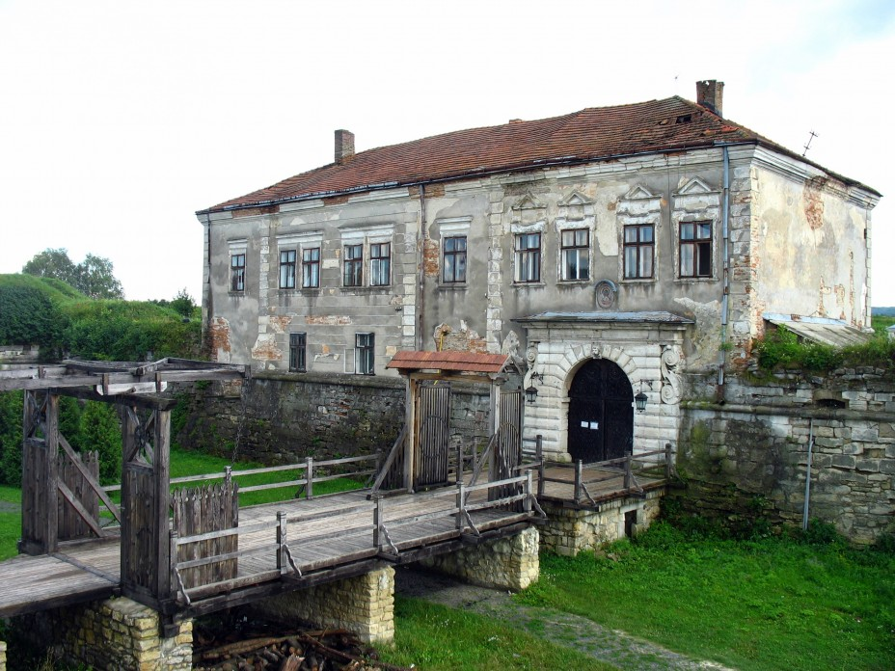
Zolochiv Castle is situated on a hill at the confluence of two small rivers in the south-eastern part of Zolochiv ( 66 km from Lviv ). It was built as a citadel with bastions in the 1630s by Jakub Sobieski.In 1672, the castle was taken after a 6-days siege by the Turks under Kapudan Pasa. Three years later, it survived a new siege by the Ottoman army. Inside Zolochiv Castle you can see a newly restored Chinese palace, a diminutive mauve-colored rotunda flanked by one-storey wings. It was built in late 17th century as Jan III's gift to his French-born wife Marysenka. After Jakub Ludwik Sobieski's death in 1737, the castle passed to the Radziwill princely family and then (in 1801) to Count Lukash Komarnitski whose heirs sold it to the Austrian crown in 1834. From this date the castle was adapted for use as a hospital and barracks. In the days of Austro-Hungarian empire it was turned into a prison and later became a grim prison under Stalin. A memorial and an exhibition to commemorate those who perished here can now be seen in the castle as well as a chapel outside the the castle walls.
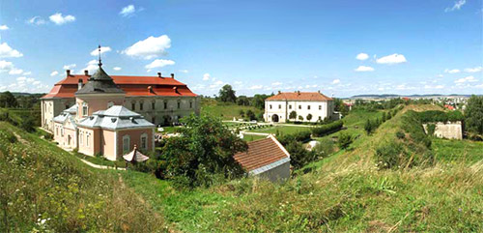
From the bastions you can see surrounding countryside and the town of Zolochiv. You can also see the old magic stones in the castle courtyard. One has engraved inscriptions in unknown language. On other stone 2 chaplets are represented - sloe and from living flowers which interlaced as if weddings rings. It also has a hole in the middle that will help fulfill your wishes if you put your finger there and turn.

